***SRS FOR ONLINE AUCTION SYSTEM***

***PROJECT FOR –***

**SOFTWARE ENGINEERING (SEM IV)**

***SUBMITTED TO -***

**DR. POOJA JAIN**

***SUBMITTED BY-***

***AISHIT DUA BT17CSE078***

***SUPRIYA VENKATESH BT17CSE106***

***Introduction:***

An **auction** is a process of buying or selling goods or services by offering them up

for bid, taking bids, and then selling the item to the highest bidder. There are

several different types of auctions and certain rules exist for each auction. There

are variations for an auction which might include minimum price limit (least bid),

maximum price limit, time limitations etc. Depending upon the auction method,

the bidder can participate remotely or in person. Remote auction includes

participating through the telephone, mail, and the internet. Shopping online has

been increasing on an exponential scale. Online auction system is also increasing

rapidly. Online auction is becoming more and more popular in electronic

commerce and hence its system must increase its quality and security. The online

auction system is a model where we participate in a bid for products and service.

This auction is made easier by using online software which can regulate processes

involved. There are several different auction methods or types and one of the most popular methods is English auction system. This system has been designed to be

highly-scalable and capable of supporting large numbers of bidders in an active

auction. Online Auctioning System has several other names such as e-Auctions,

electronic auction etc. The requirement for online auction or online bidding can be

more accurately specified by the client. It should be healthy and will be a good

practice when it is made more transparent as a matter of fact. Online Bidding has

become more wide spread in all sorts of industrial usage. It not only includes the

product or goods to be sold, it also has services which can be provided. Due to

their low cost this expansion made the system to grow. Online bidding has become

a standard method for procurement process. Bidders can be maintained in a single

database according to the preference, and they can be monitored. User’s data can

be maintained in a confidential way for validity and integrity of contractual

documentation. In this project, there is a gist of a module of online auctioning

system.

***Purpose:***

The purpose of this document is to present a detailed description of the Online Auction

System. It will explain the purpose and features of the system, the interfaces of the

system, what the system will do, the constraints under which it must operate and how

the system will react to external stimuli. This document also contains the functionalities

and requirements of the system.

***Scope:***

This software system will provide the specifications of a module for the Online Auction

System for a number of customers. This system will be designed to maximize the

customer’s productivity by providing various options such as bid, sell, etc. which or else

had to be done manually. More specifically, this system is designed to allow the

individual users to login with their unique email ID and password which is provided to the

at the time of making a new account.

***Objectives:***

The objective is to develop an unadorned auctioning site where many kinds of products

can be listed, bidded and sold and to provide value added services to all the customers.

* Secure registration of all users including a personal profile.
* Prior to each bid, the user’s bank or credit account must be authenticated for.
* Available balance required for the bid.
* Complete Search/Site Map of the entire site for easy access.

***External Interfaces:***

* Requires a system with working internet connection.
* Requires a browser (preferably chrome) on the system to open the website.
* Requires a fast internet connection for the uninterrupted user experience.

***Performance Requirements:***

The system has been designed such that it will give the most optimized performance with the following:

* Works on a system with CHROME, MOZILLA, IE and all the other popular BROWSERS.
* Since it is a portable, it can be opened in any operating system and it will provide the same performance.
* Source Code – For working in dev mode and reading the code, the best IDE is INTELLIJ for JAVA, for working on the web dev and php documents we can use the ATOM IDE.

***Functional Requirements:***

**User side**:

Req 1: Login to a new session UC 1: login();

Req 2: Add a new user UC 2: Adduser();

Req 3: Bid on a specific item UC3: Bid();

Req 4: View listed item to buy UC 4: Buy();

Req 5: Sell an item UC 5: Sell();

Req 6: Auction items that were listed today UC 6: NewAuctionItemToday();

Req 7: Auction items ending today UC 7: NewAuctionItemsEndDay();

Req 9: View the list of all items UC 9: ViewBidItems();

**Admins side**:

Req 8: View the list of all present customers UC 8: ViewCustomer();

Req 9: View the list of all items UC 9: ViewBidItems();

Req10: Remove a particular listed item UC 10: RemoveItem();

Req11: View the profile of a particular customer UC 11: ViewProfile();

Req12: Ban a particular customer permanently UC 12: BanProfile();

Req 6: Auction items that were listed today UC 6: NewAuctionItemToday();

Req 7: Auction items ending today UC7: NewAuctionItemsEndDay();

***Design Constraints:***

* Though the website has been designed with optimized performance in mind, the major constraint is that it is not mobile friendly.
* The site has been created with all basic web dev technologies, and even JAVA which is a really robust language, but due to the bandwidth of the server allotted, the website cannot handle more than 150 users at a time.
* Though when a customer logs in he can buy and sell on the same session, but simultaneous bidding and selling on different tabs cannot be performed.
* If a user has logged in from a device. he cannot login from another device until he logs out from that device itself i.e. A user can login only from one device at a time.

***Description of the individual use cases:***

* **Login()**:

USE CASE NUMBER: 1

ACTORS: CUSTOMER

This function is used to login to a new session. The user is expected to enter the user id and password. This finishes the successful authentication and redirects the user to the homepage. On unsuccessful login, the user is directed to the forgot password page where he has to reset his password. After that, consecutive login will take place with the new password.

* **AddUser()**:

USE CASE NUMBER: 2

ACTORS: NEW MEMBER: (NOT A CUSTOMER)

This function is a subset of the login(). In this, the new user is prompted to add his account in the website. This includes creating a new user id and password for the accessing of the individual account in the webite.

* **Bid():**

USE CASE NUMBER: 3

ACTORS: CUSTOMER

This function is for bidding of the items. The customer upon logging in, is directed to the homepage and the is expected to place his bid on the current items which are being bid upon at the moment. Upon successful bid, the item will be sold to the customer.

* **Sell():**

USE CASE NUMBER: 4

ACTORS: CUSTOMER

This function is for selling of a specific item. Here, the customer is selling his own individual item. The user is expected to set a basic amount called starting bid which is the minimum amount above which the item has to be bidded upon by the other customers who are interested in the product.

* **Buy():**

USE CASE NUMBER: 5

ACTORS: CUSTOMER

This function is for buying of an item. Here, upon successful login, the user goes through the list of all the items and then proceeds to the list of current items which are being sold. After deciding what to buy, the user is expected to place a bid which is more than the minimum bid for that particular item.

* **NewAuctionItemToday():**

USE CASE NUMBER: 6

ACTORS: CUSTOMER, ADMIN

This function is used to display all the items which upon which the bidding/selling is taking place on that particular day. The list of all the new items put up for the auction is displayed in this.

* **NewAuctionItemsEndDay():**

USE CASE NUMBER: 7

ACTORS: CUSTOMER, ADMIN

This function is also used to display all the items upon which the bidding/selling is supposed to be taking place on that particular day. The list of all the items whose scope ends of that particular day is displayed.

* **ViewCustomer():**

USE CASE NUMBER: 8

ACTOR: ADMIN

This function is from the admins side. This is for the admin to check the list of all the customers who have an account on the website. The admin has a choice to see customers through sorting also.

* **ViewBidItems():**

USE CASE NUMBER: 9

ACTORS: CUSTOMER,ADMIN

This function is from the side of the admin and the customer. This is used to view the list of all the bidded items for the admin at any point of time. All the items from the above mentioned modules will be accessible to the admin via the function.

* **RemoveItem():**

USE CASE NUMBER: 10

ACTORS: ADMIN

If the item is not within the set standards of the particular website, then the administrator can remove the item. This only available for the admin. The admin can remove items which are currently available.

* **ViewProfile():**

USE CASE NUMBER: 11

ACTOR: ADMIN

This function is used to view any particular profile of any particular customer. By this, the admin will have direct access to the customer’s profile.

This is used as a display function access.

* **BanProfile():**

USE CASE NUMBER: 12

ACTORS: ADMIN

This is the function which gives the admin to authority to ban a profile when it fails to meet the necessary requirements. In this process, the ID is searched on the database and then it is banned.

xxx--- USE CASE DIAGRAM ON THE NEXT PAGES---xxx

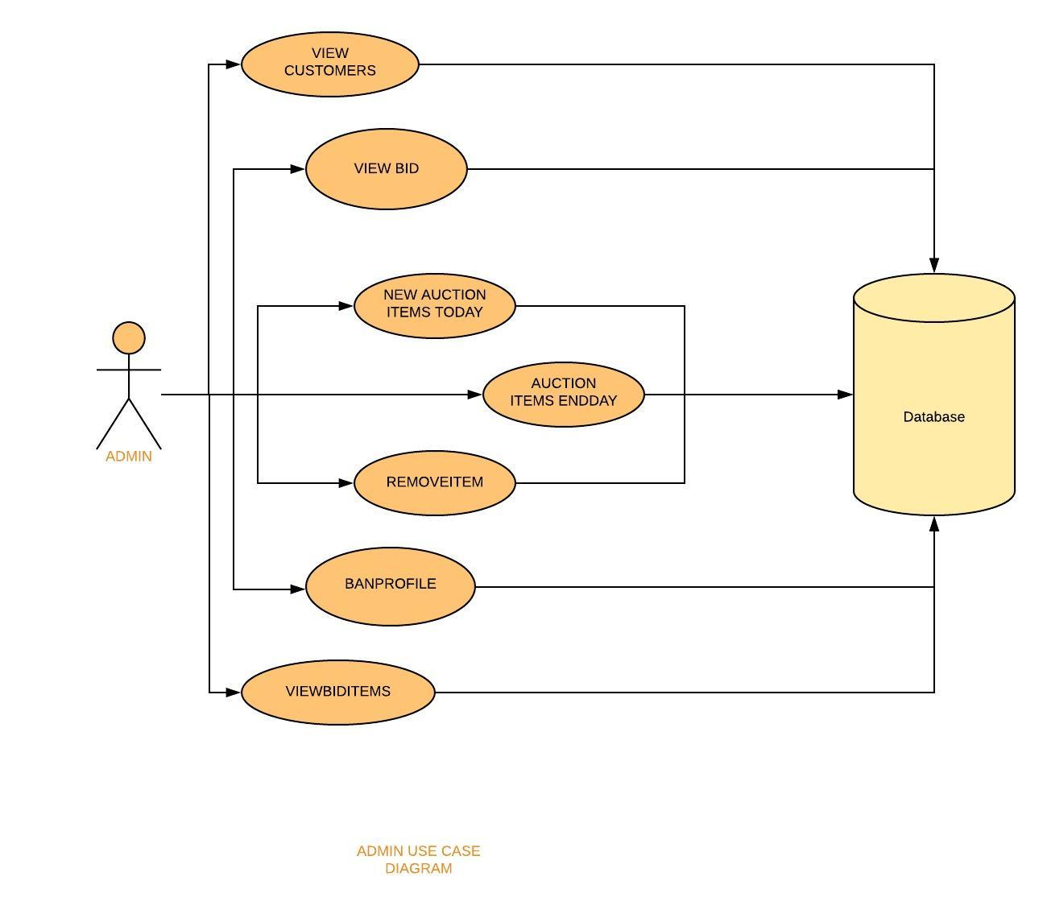

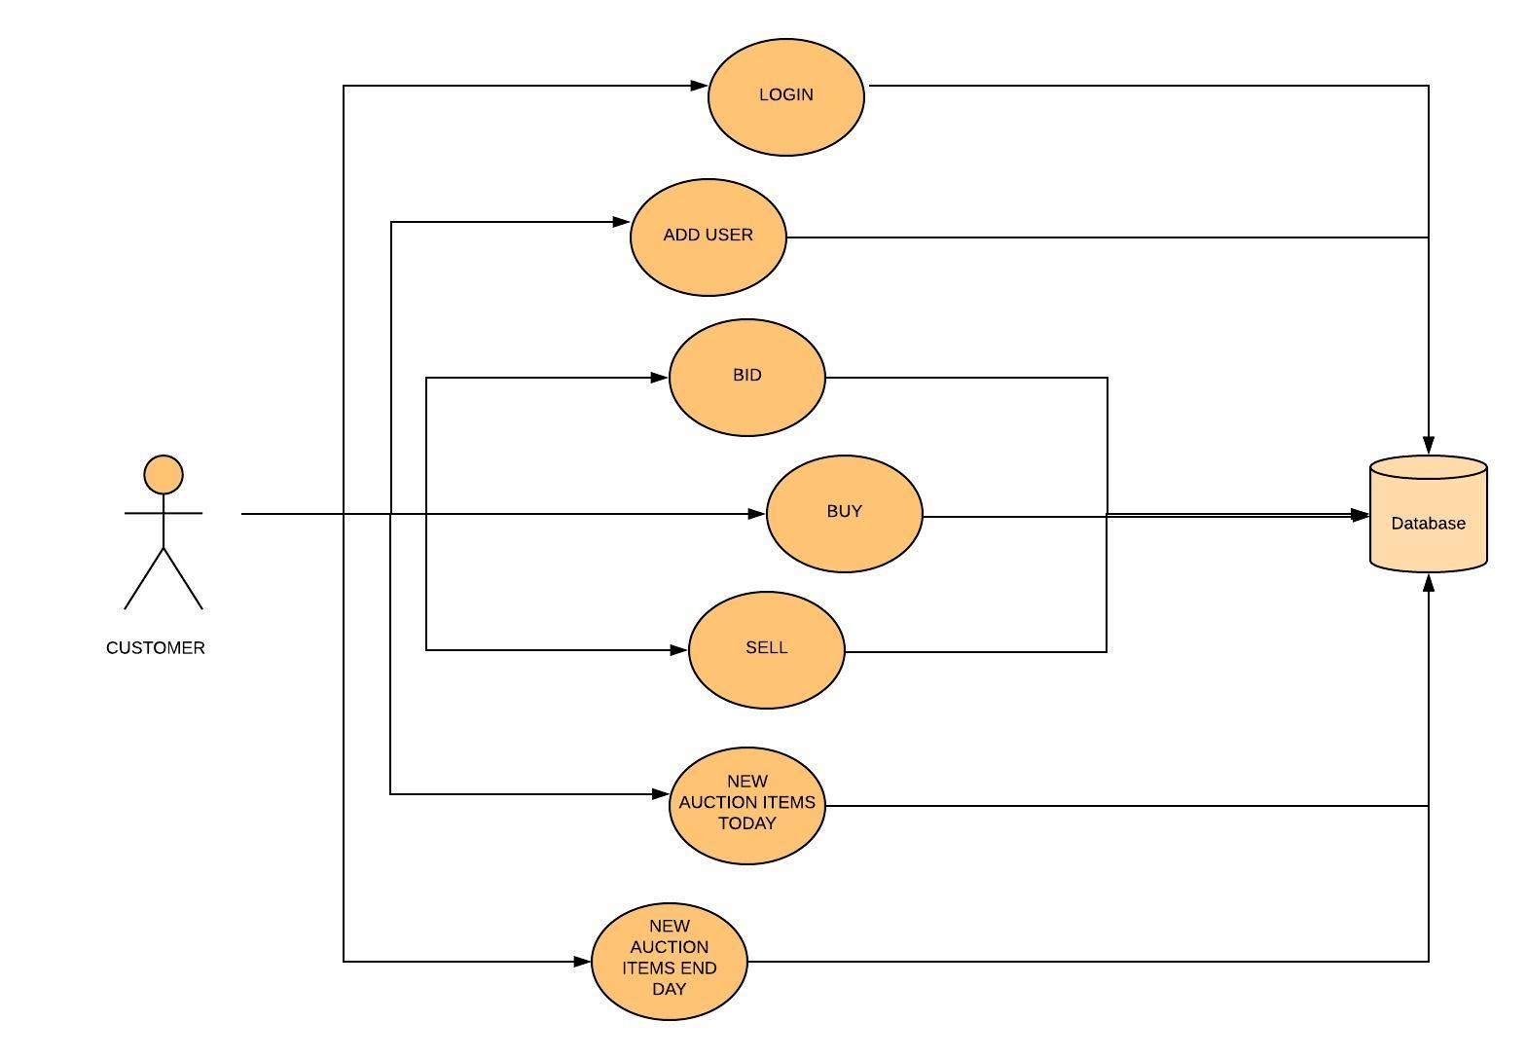

USER SIDE USE CASE DIAGRAM

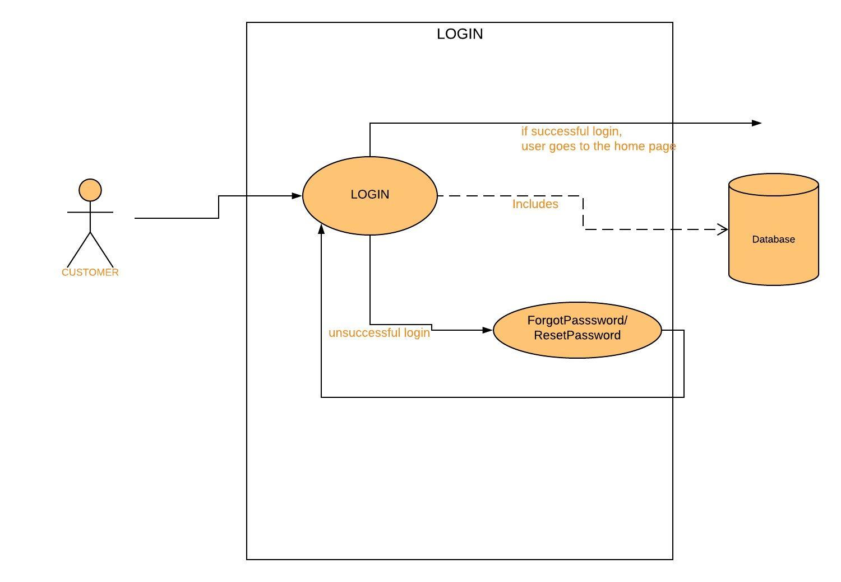

UC1: LOGIN

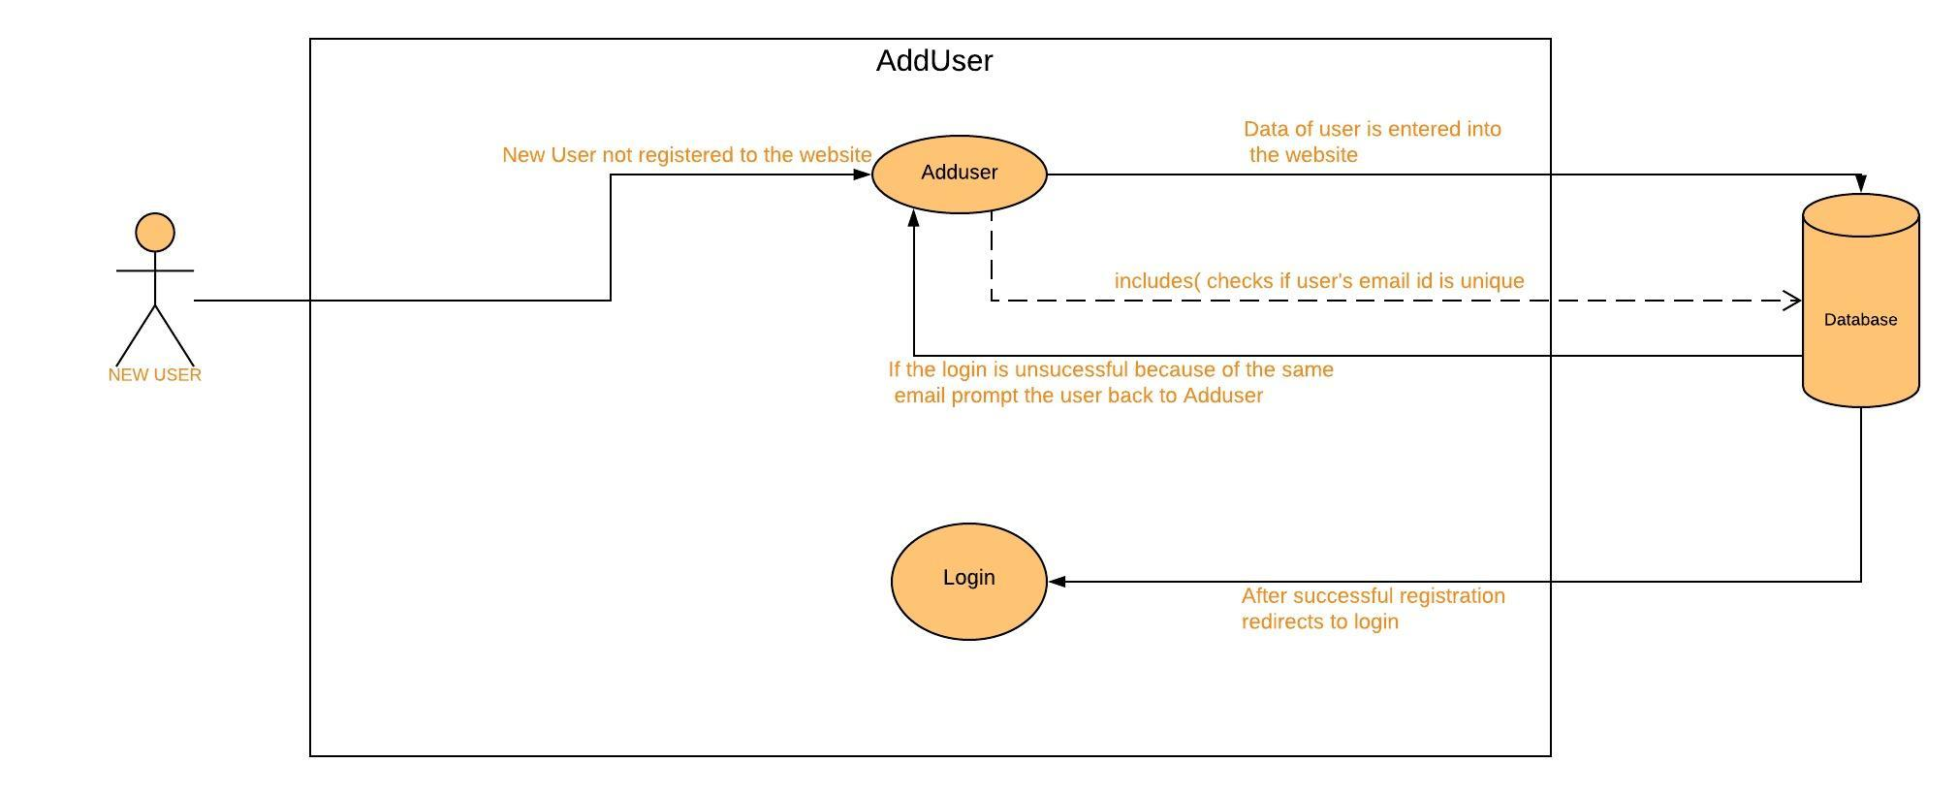

UC2: ADDUSER

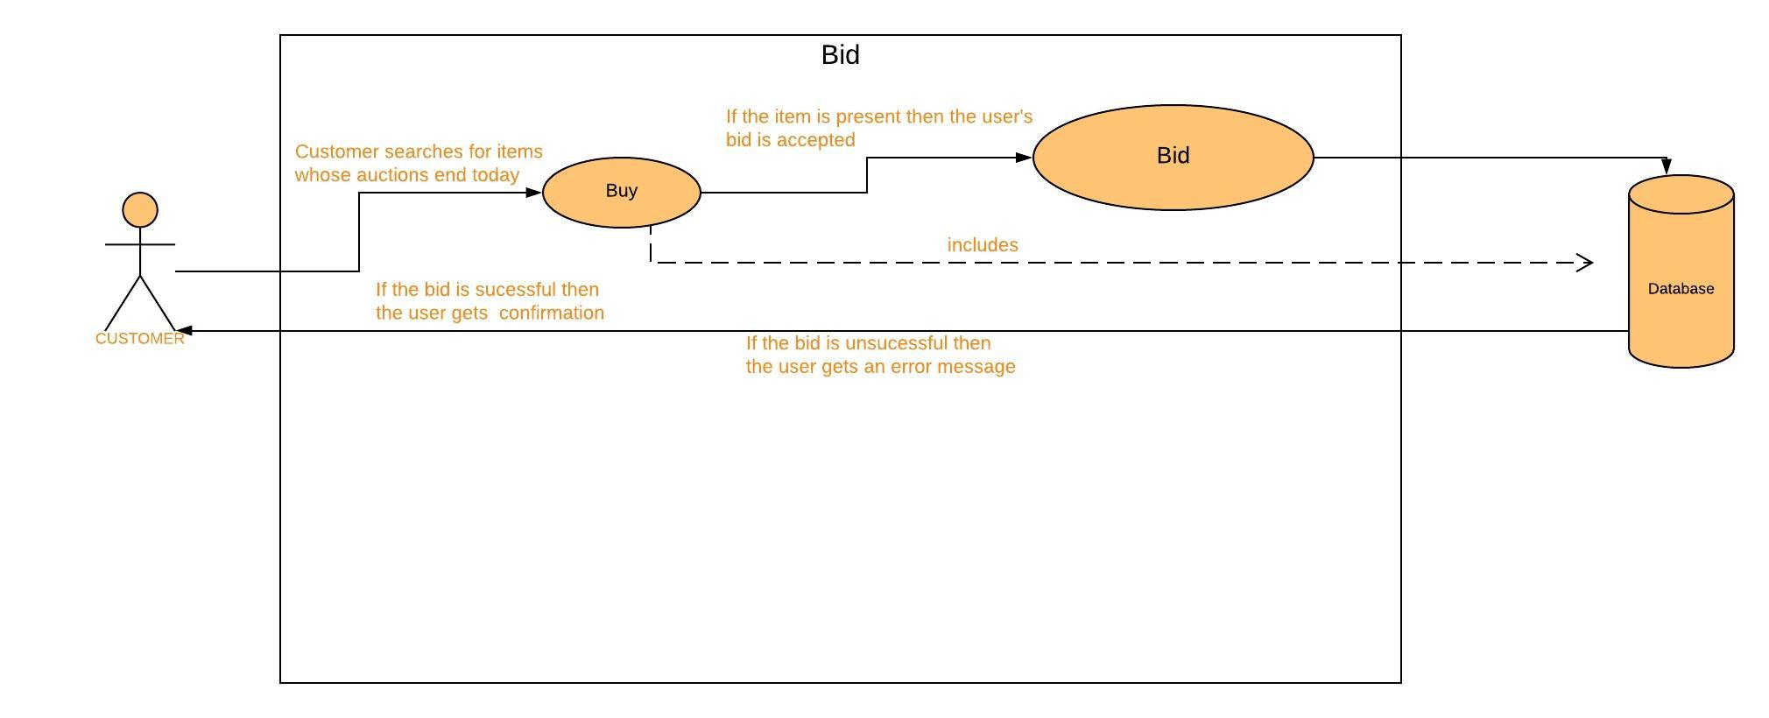

UC3: BID

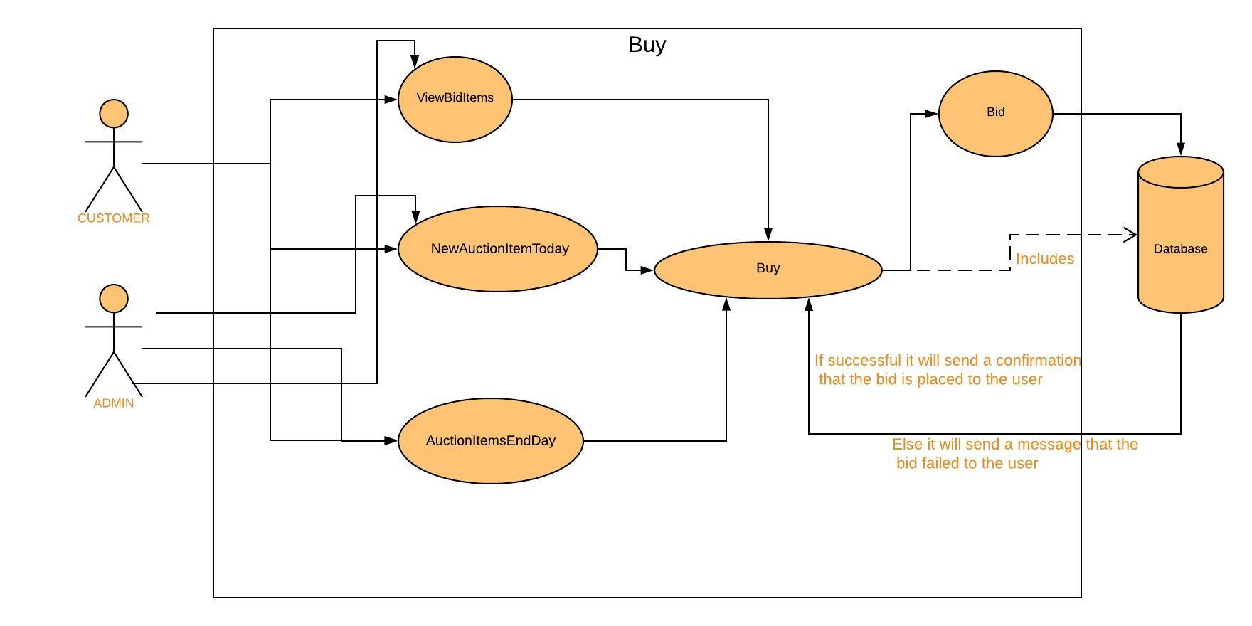

UC4: BUY

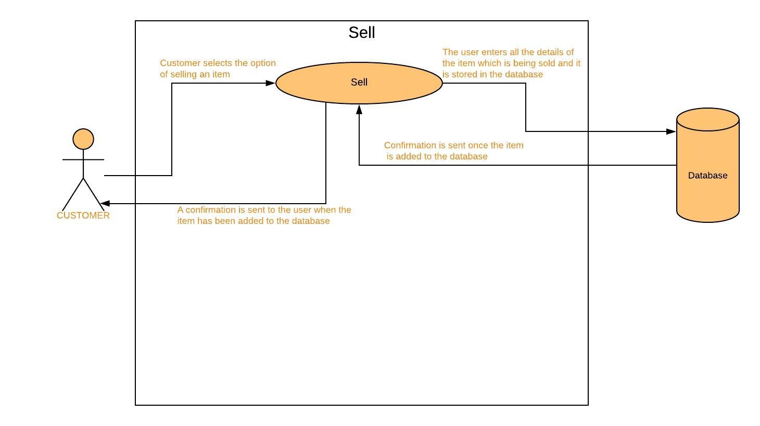

UC5: SELL

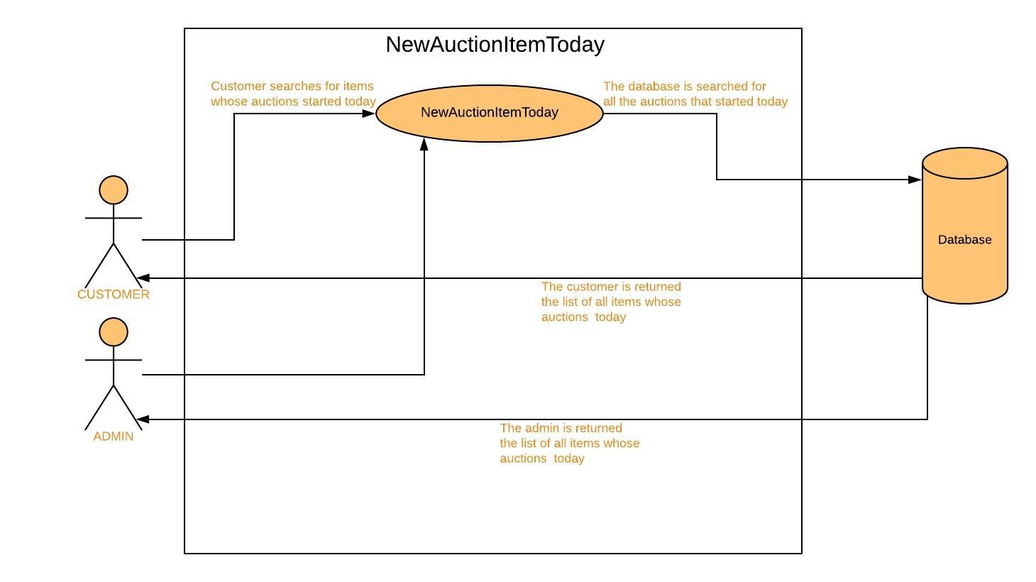

UC6: NEWAUCTIONITEMTODAY

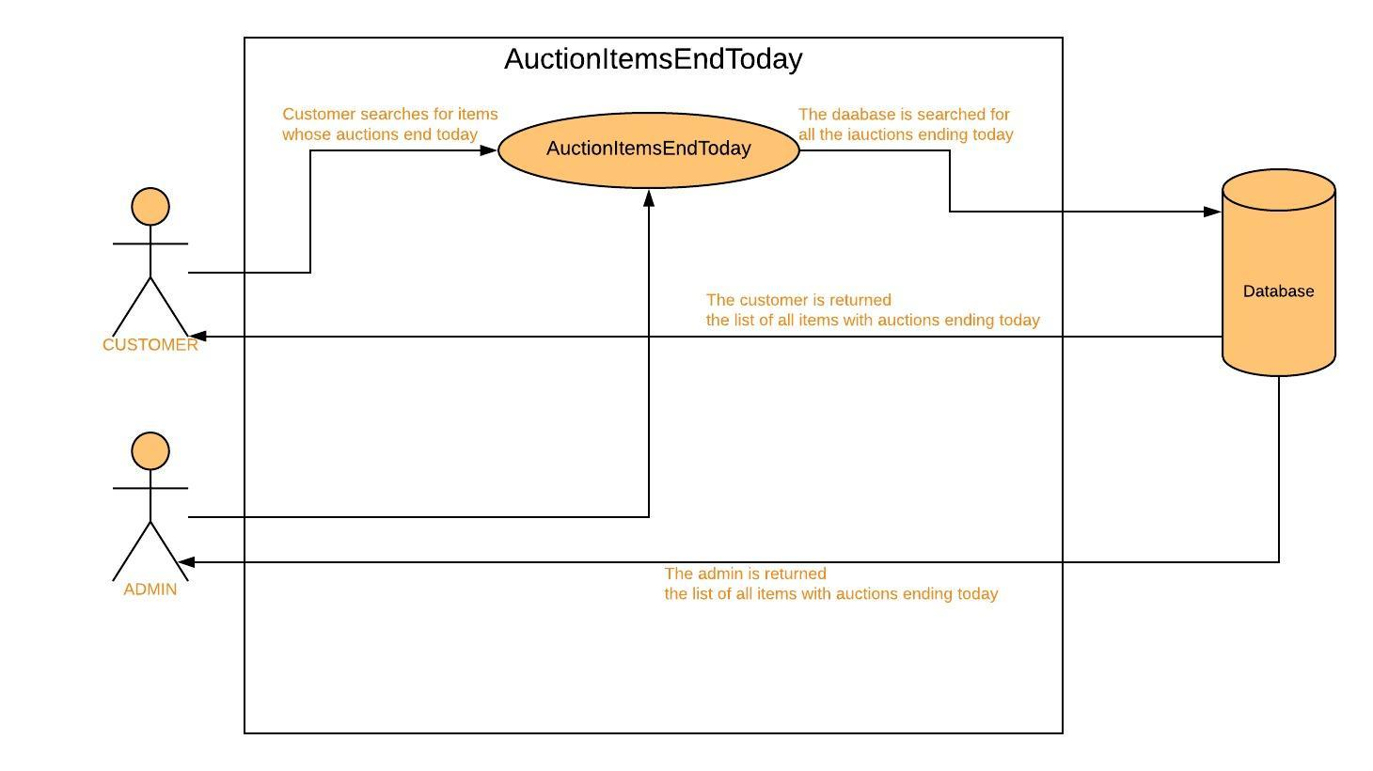

UC7: AUCTIONITEMSENDTODAY

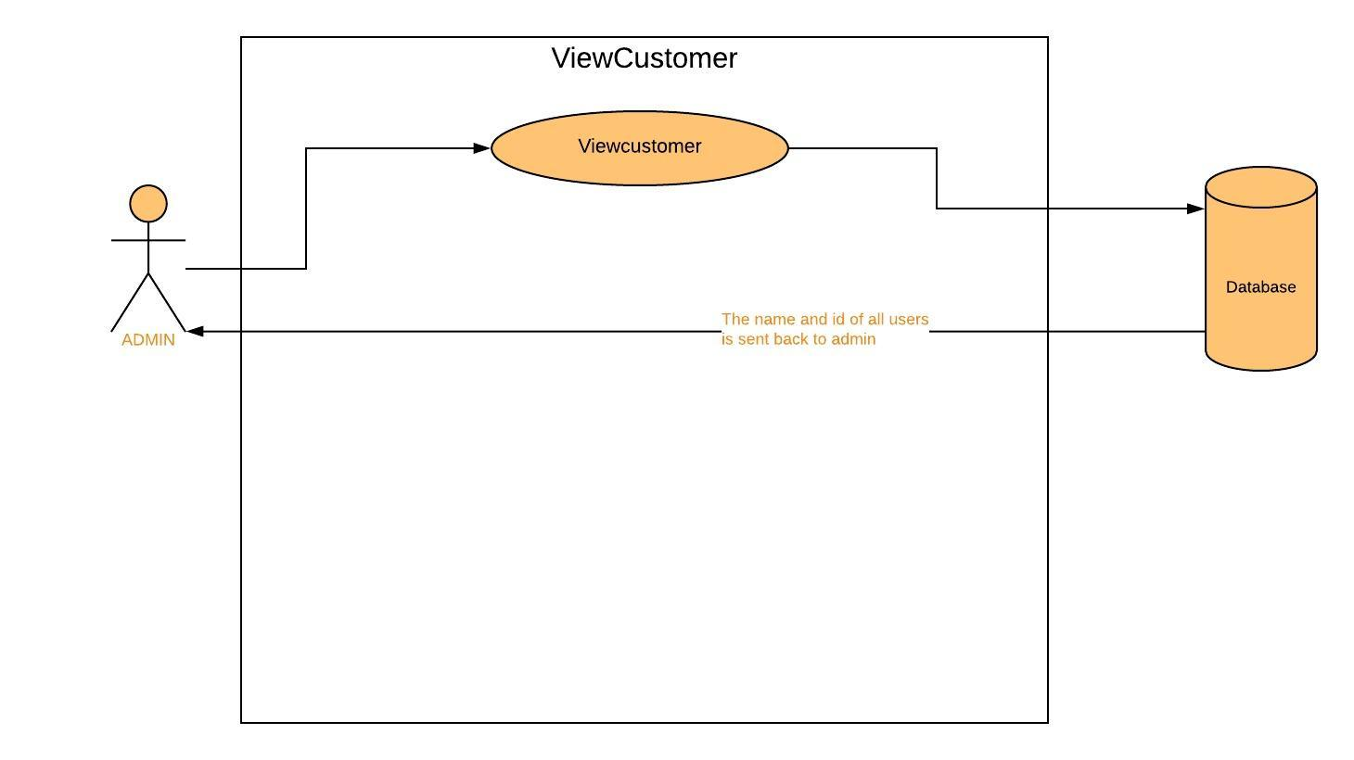

UC8: VIEWCUSTOMER

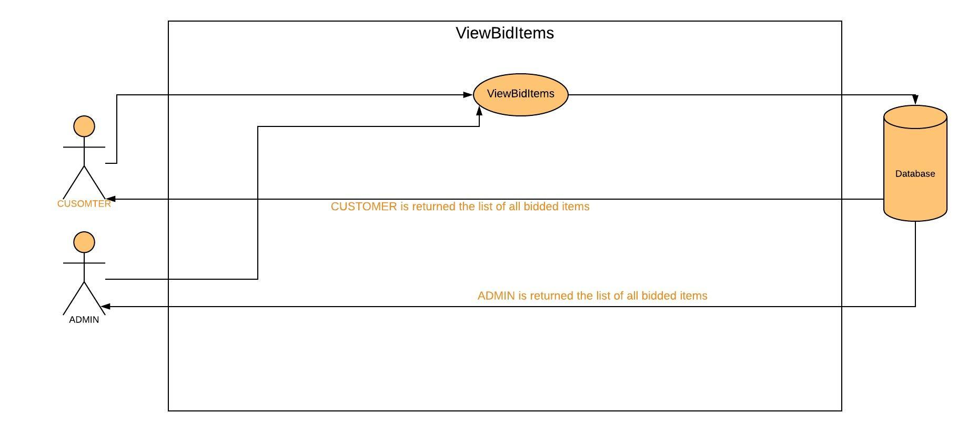

UC9: VIEWBIDITEMS

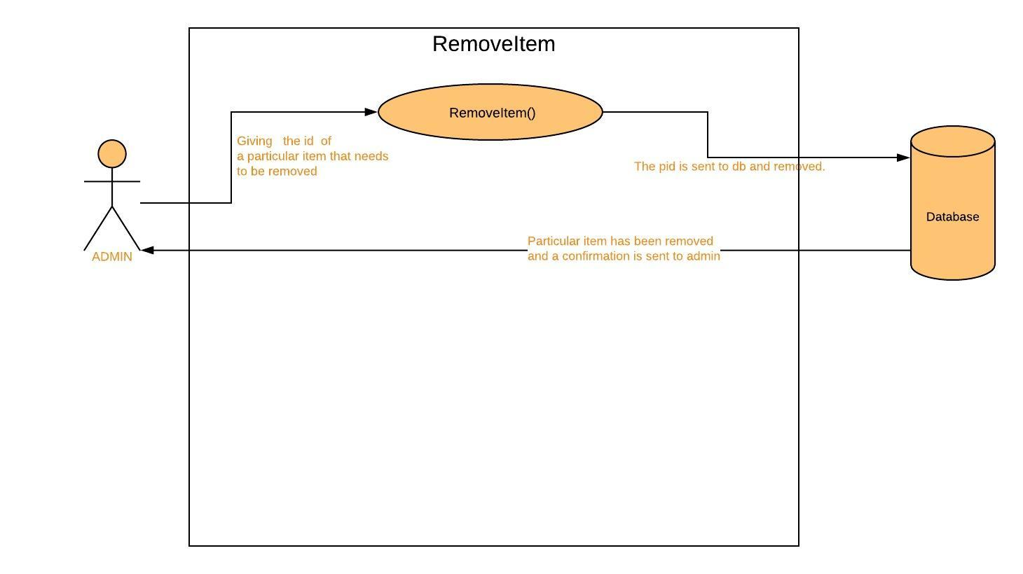

UC10: REMOVEITEM

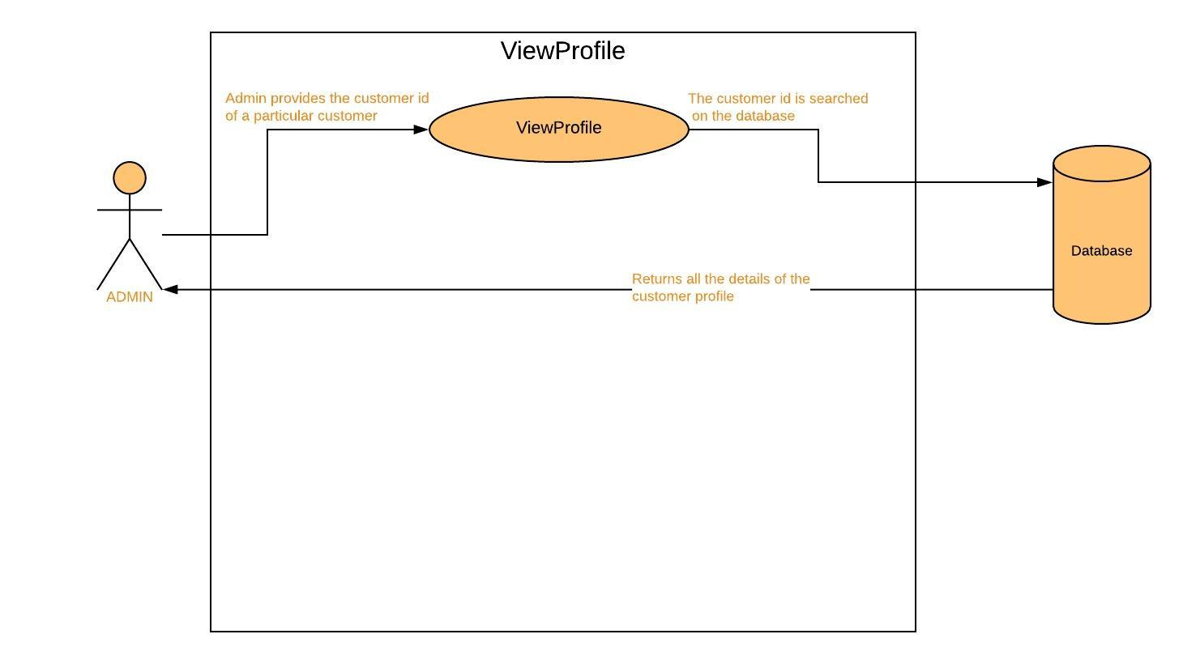

UC11: VIEWPROFILE

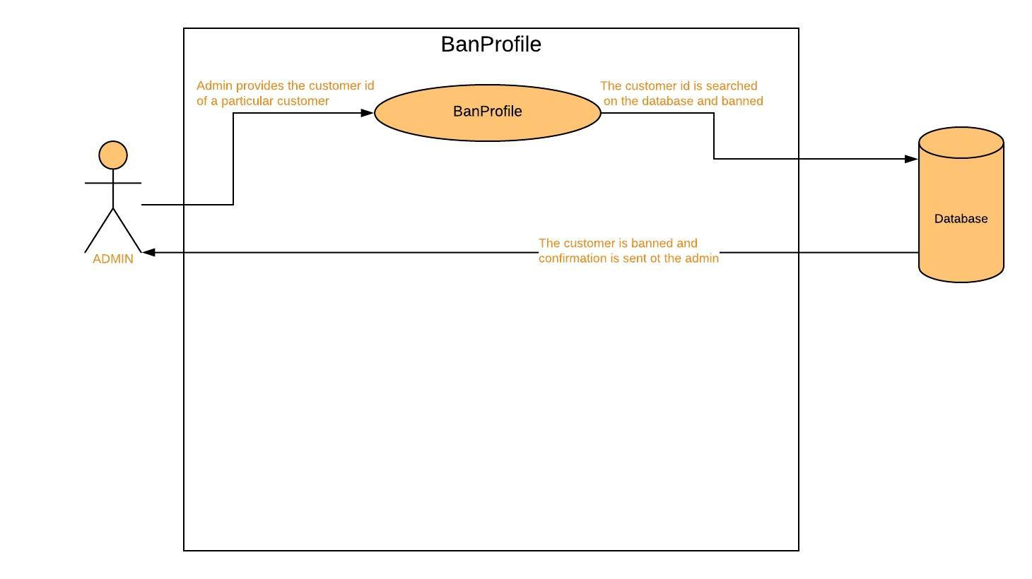

UC12: BANPROFILE

***PROCESS MODEL – THE WATERFALL MODEL***

In this online auction system, the main process model we employ is the waterfall mode.

The waterfall model basically can be defined as-

The waterfall model, sometimes called the classic life cycle, suggests a systematic,

sequential approach to software development that begins with customer specification of requirements and progresses through planning, modeling, construction, and deployment, culminating in ongoing support of the completed software.

The main reason for choosing the waterfall process model would be because the requirements for a problem are well understood—when work flows from communication through deployment in a reasonably linear fashion.

The requirement of the system is already well defined as stated in our use case diagrams etc. Also, the only disadvantage of using the disadvantage of the process

model is that the software won't be available till late in the development phase, but it is okay since we are only delivering one increment of our software after extensive testing.

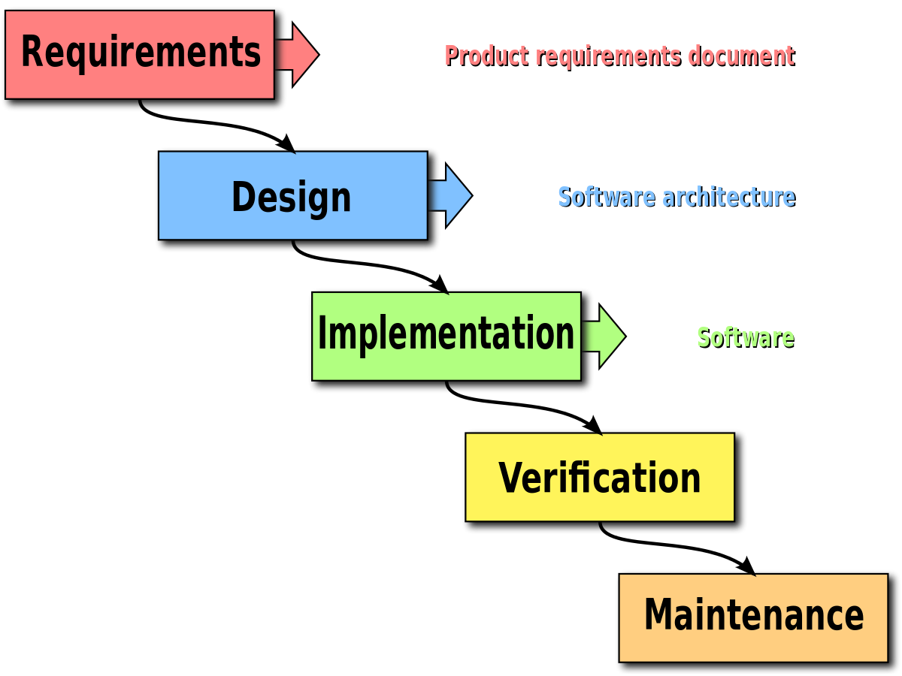

***THE TYPE OF AGILE FRAMEWORK – SCRUM***

In our project which is Online Auction System, the Scrum framework can be applied suitably.

Scrum is a framework within which people can address complex adaptive problems,

while productively and creatively delivering products of the highest possible value.

In this, small working teams are organized to "maximize communication, minimize overhead,

and maximize the strength of sharing tacit and informal knowledge. Often thought of as an agile project management framework,

Scrum describes a set of meetings, tools, and roles that work in concert to help teams structure and manage their work.

There are various prerequisites for choosing scrum. This employs a backlog in which there is a list of project requirements

that provide buisness value. Items can be added anytime. This makes it customer friendly.

The specifications are already taken care of in the functional requirements and the use cases, but if there are any additional

features, they can always be added in the list of backlog.

The heart of Scrum is a Sprint,

a time-box of two weeks or one month during which a potentially releasable product increment is created.

A new Sprint starts immediately after the conclusion of the previous Sprint.

During this time, the backlog items that the sprint work units address are frozen. All the data from the use cases

are implemented here.

Meetings are organized in which the modules of the system can be looked into. After the completion of every backlog,

the next accomplishments of the backlog list is discussed. For example, after the completion of the login() module,

a scrum meeting can be held.

The Sprint Retrospective occurs after the Sprint Review and prior to the next Sprint Planning.

In this meeting, the Scrum Team is to inspect itself and create a plan for improvements to be enacted during the subsequent Sprint.

